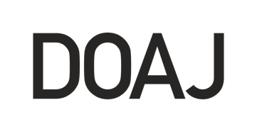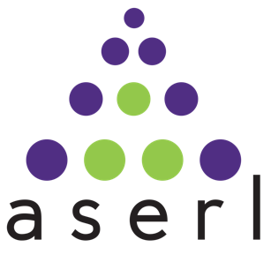
Association of Southeastern Research Libraries and Directory of Open Access Journals forge new partnership
8 March 2021, Atlanta - The Directory of Open Access Journals (DOAJ) is excited to announce a new partnership with the Association of Southeastern Research Libraries (ASERL). The arrangement shines a spotlight on the importance of open access at a time when both libraries and the organizations on which they depend -- such as DOAJ -- are facing unprecedented financial risks.

“We are delighted to announce this new agreement today with the Association of Southeastern Research Libraries and greatly appreciate their support of our work. Partnerships such as this are key to the future of DOAJ, open access, and scholarly publishing,” said Lars Bjørnshauge, DOAJ Founder and Managing Director.

As a free and independent database, DOAJ indexes over 15,000 peer-reviewed open access journals from around the world. ASERL is one of the largest regional research consortia in the United States. Its members are world-renowned libraries at research-intensive universities, with a vested interest in open access and open science.

The COVID-19 pandemic and the increased demand for vetted, high-quality online academic research has highlighted the critical importance of support for essential library infrastructure services such as DOAJ. This agreement will be vital in creating a smooth path for such support to flow directly from ASERL members to DOAJ. Under the new partnership ASERL will be able to offer support for DOAJ to consortia members at a substantial discount.

“ASERL libraries have long supported improvements in scholarly communication and the infrastructure that undergirds the research, teaching and learning missions of our member institutions. Facilitating investments in community-based organizations like DOAJ clearly advances those goals,” commented Jan Lewis, Director of Academic Library Services at East Carolina University and President of ASERL’s Board of Directors for 2020-2021.

About ASERL
Founded in 1956, ASERL is one of the largest regional research library consortia in the United States, serving 37 institutional members in 11 states. ASERL cultivates important conversations and nurtures relationships among library leaders in the Southeast. By working together, ASERL members provide and maintain top-quality resources and services for the students, faculty, and citizens of their respective communities. ASERL is housed in the Robert W. Woodruff Library at Emory University in Atlanta, Georgia. See www.aserl.org for more information.

About DOAJ
DOAJ is a community curated online directory that indexes and provides access to high quality, open access, peer reviewed journals. DOAJ deploys more than one hundred carefully selected volunteers from among the community of library and other academic disciplines to assist in the curation of open access journals. This independent database contains over 15,000 peer-reviewed open access journals covering all areas of science, technology, medicine, social sciences, arts and humanities. DOAJ is financially supported worldwide by libraries, publishers and other like-minded organizations. DOAJ services (including the evaluation of journals) are free for all, and all data provided by DOAJ are harvestable via OAI/PMH and the API. See https://doaj.org/ for more information.

Contacts:

ASERL – John Burger, Executive Director
jburger@aserl.org

DOAJ - Louise Stoddard, Public Relations Officer
louise@doaj.org

