ASERL Welcomes Eric Glenn as
Visiting Program Officer for Leadership Development

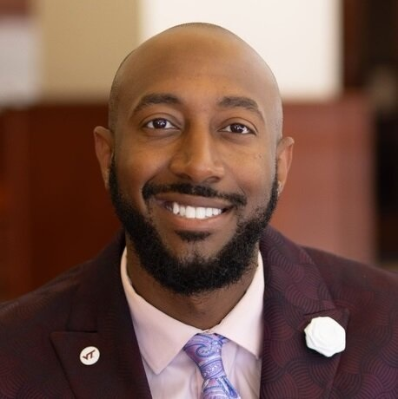
August 15, 2024 -- ALANTA -- At its recent meeting, the ASERL Board of Directors affirmed Eric Glenn, Director of Belonging, Engagement, and Organizational Development at Virginia Tech Libraries, to serve as Visiting Program Officer (VPO) for Leadership Development, starting August 19, 2024. His service will continue for approximately one year.

Since April 2023, more than 100 participants have participated in ASERL Leadership Development institutes, which focus on cultivating the talents and skills of librarians and staff from underrepresented groups. Eric himself is a proud alumnus of the program – he attended the ASERL Leadership Institutes in Atlanta (July 2023) and Chapel Hill (April 2024). His work as VPO will focus on continued engagement with his fellow alumni, to foster ongoing connections and professional growth. Most of this programming will be done online, but Eric will also assist with the upcoming leadership & networking event for Human Resources and Organizational Development professionals working in ASERL libraries that will take place in early October in Charlottesville, VA.

Mr. Glenn has a rich professional history. He has worked at Virginia Tech Libraries since October 2022 and worked in other roles at Virginia Tech since 2014. Previously he worked for the United Sates Joint Forces Command and King University. He has also been a longstanding community leader in the Virginia Tech area. He holds multiple certifications in diversity topics, and also has a Bachelors degree in neuroscience.

“I am deeply honored and truly humbled to follow in the footsteps of program officers like Brandon Britt and Karen Manning, who have set a high standard of passion and community building," noted Glenn. "My heartfelt thanks to Elaina Norlin, John Burger, and the ASERL Board for entrusting me with the role of the next Visiting Program Officer. I am genuinely excited about the opportunity to collaborate with institutions across ASERL and contribute in any way I can to advancing the field of librarianship.”
(more)
"Eric Glenn is a wonderful addition to lead the continued expansion of ASERL's leadership program,” commented Jeff Steely, Dean of Libraries at Georgia State University and ASERL Board President for 2024-25. “He has first-hand experience with the people and the programming, has great ideas for bringing in new people into the group, and dreams big about the future of research libraries. Eric will be an excellent addition to our team!”

ABOUT ASERL
Founded in 1956, ASERL is ASERL is one of the largest of regional research library consortia in the United States and recognized as a national leader in cooperative research library programming. Today, ASERL serves 39 member institutions in 12 states via highly acclaimed programming, cultivating important conversations, and nurturing relationships among library leaders in the Southeast. By working together, ASERL members provide and maintain unique, top-quality resources and services for the students, faculty, and citizens of their respective communities. ASERL is housed within the Robert W. Woodruff Library at Emory University in Atlanta, Georgia.

###

